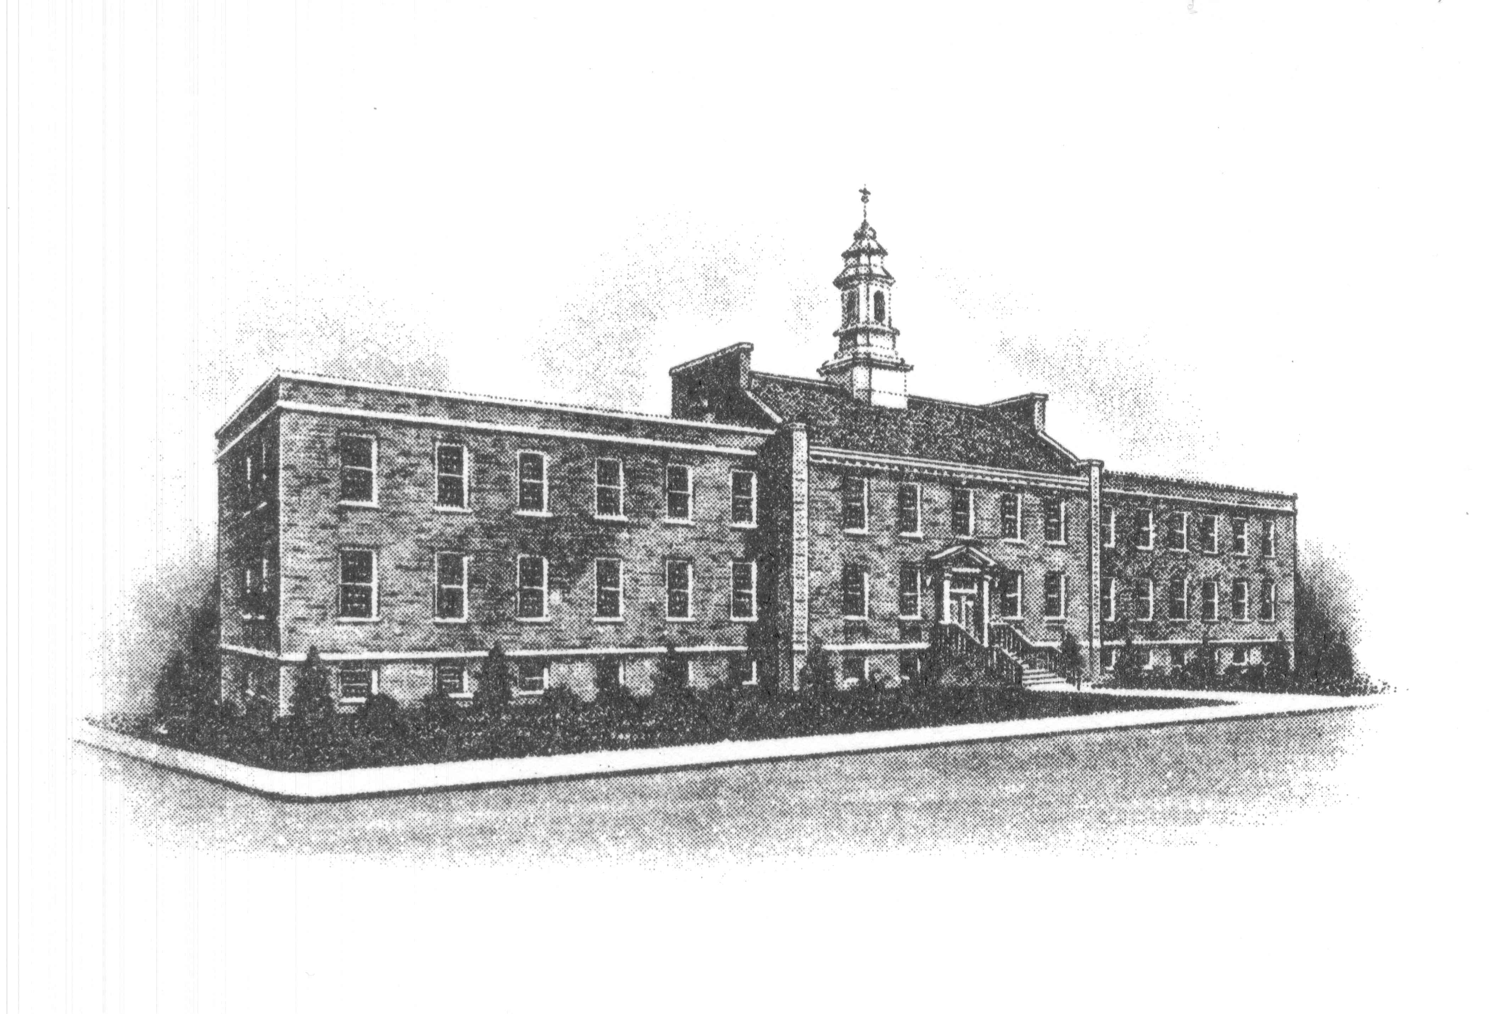
Sayreville Economic and
Redevelopment Agency
167 Main Street
Sayreville, NJ 08872
Phone: 732-721-6444
FAX: 732-390-0509

BOROUGH OF SAYREVILLE
NOTICE OF ELECTRONIC MEETING OF
SAYREVILLE ECONOMIC & REDEVELOPMENT AGENCY

Please be advised that the Sayreville Economic & Redevelopment Agency will hold its regular meeting on Thursday, December 10th at 6:30 p.m. via electronic communications equipment.

Pursuant to the provisions of the New Jersey Open Public Meetings Act, N.J.S.A. 10:4-8(b), this meeting will be held via Zoom. Due to the COVID-19 pandemic, no members of the public shall be permitted to physically attend the meeting. The public, however, is invited to attend the meeting by the following teleconference:

Dial In Numbers:
312-626-6799 or 646-558-8656 or 301-715-8592

Enter Meeting ID:
919 7631 8464

Select the ‘#’ key when prompted for Participant ID

Meeting Password: 121633

To help keep the meeting as organized as possible, residents who wish to speak in one of the public portions are to press *9 which will notify us that a person from the public wishes to speak. At that time, you will be asked for your name and address and be limited to the 5 minute comment period.

We understand this may be an unfamiliar process for you and ask that you be patient. If you prefer not to participate vocally you can email your questions to the SERA Secretary at joank@sayreville.com no later than 12:00 noon, Tuesday, December 8th so your questions or comments can be read into the record. The agenda for the meeting will be posted on the Borough website for your review.

We apologize for any inconvenience but in order to keep the government operating as normal as possible, this is the best available method to accommodate the public.

Thank you for your cooperation and understanding.

SAYREVILLE ECONOMIC REDEVELOPMENT AGENCY

