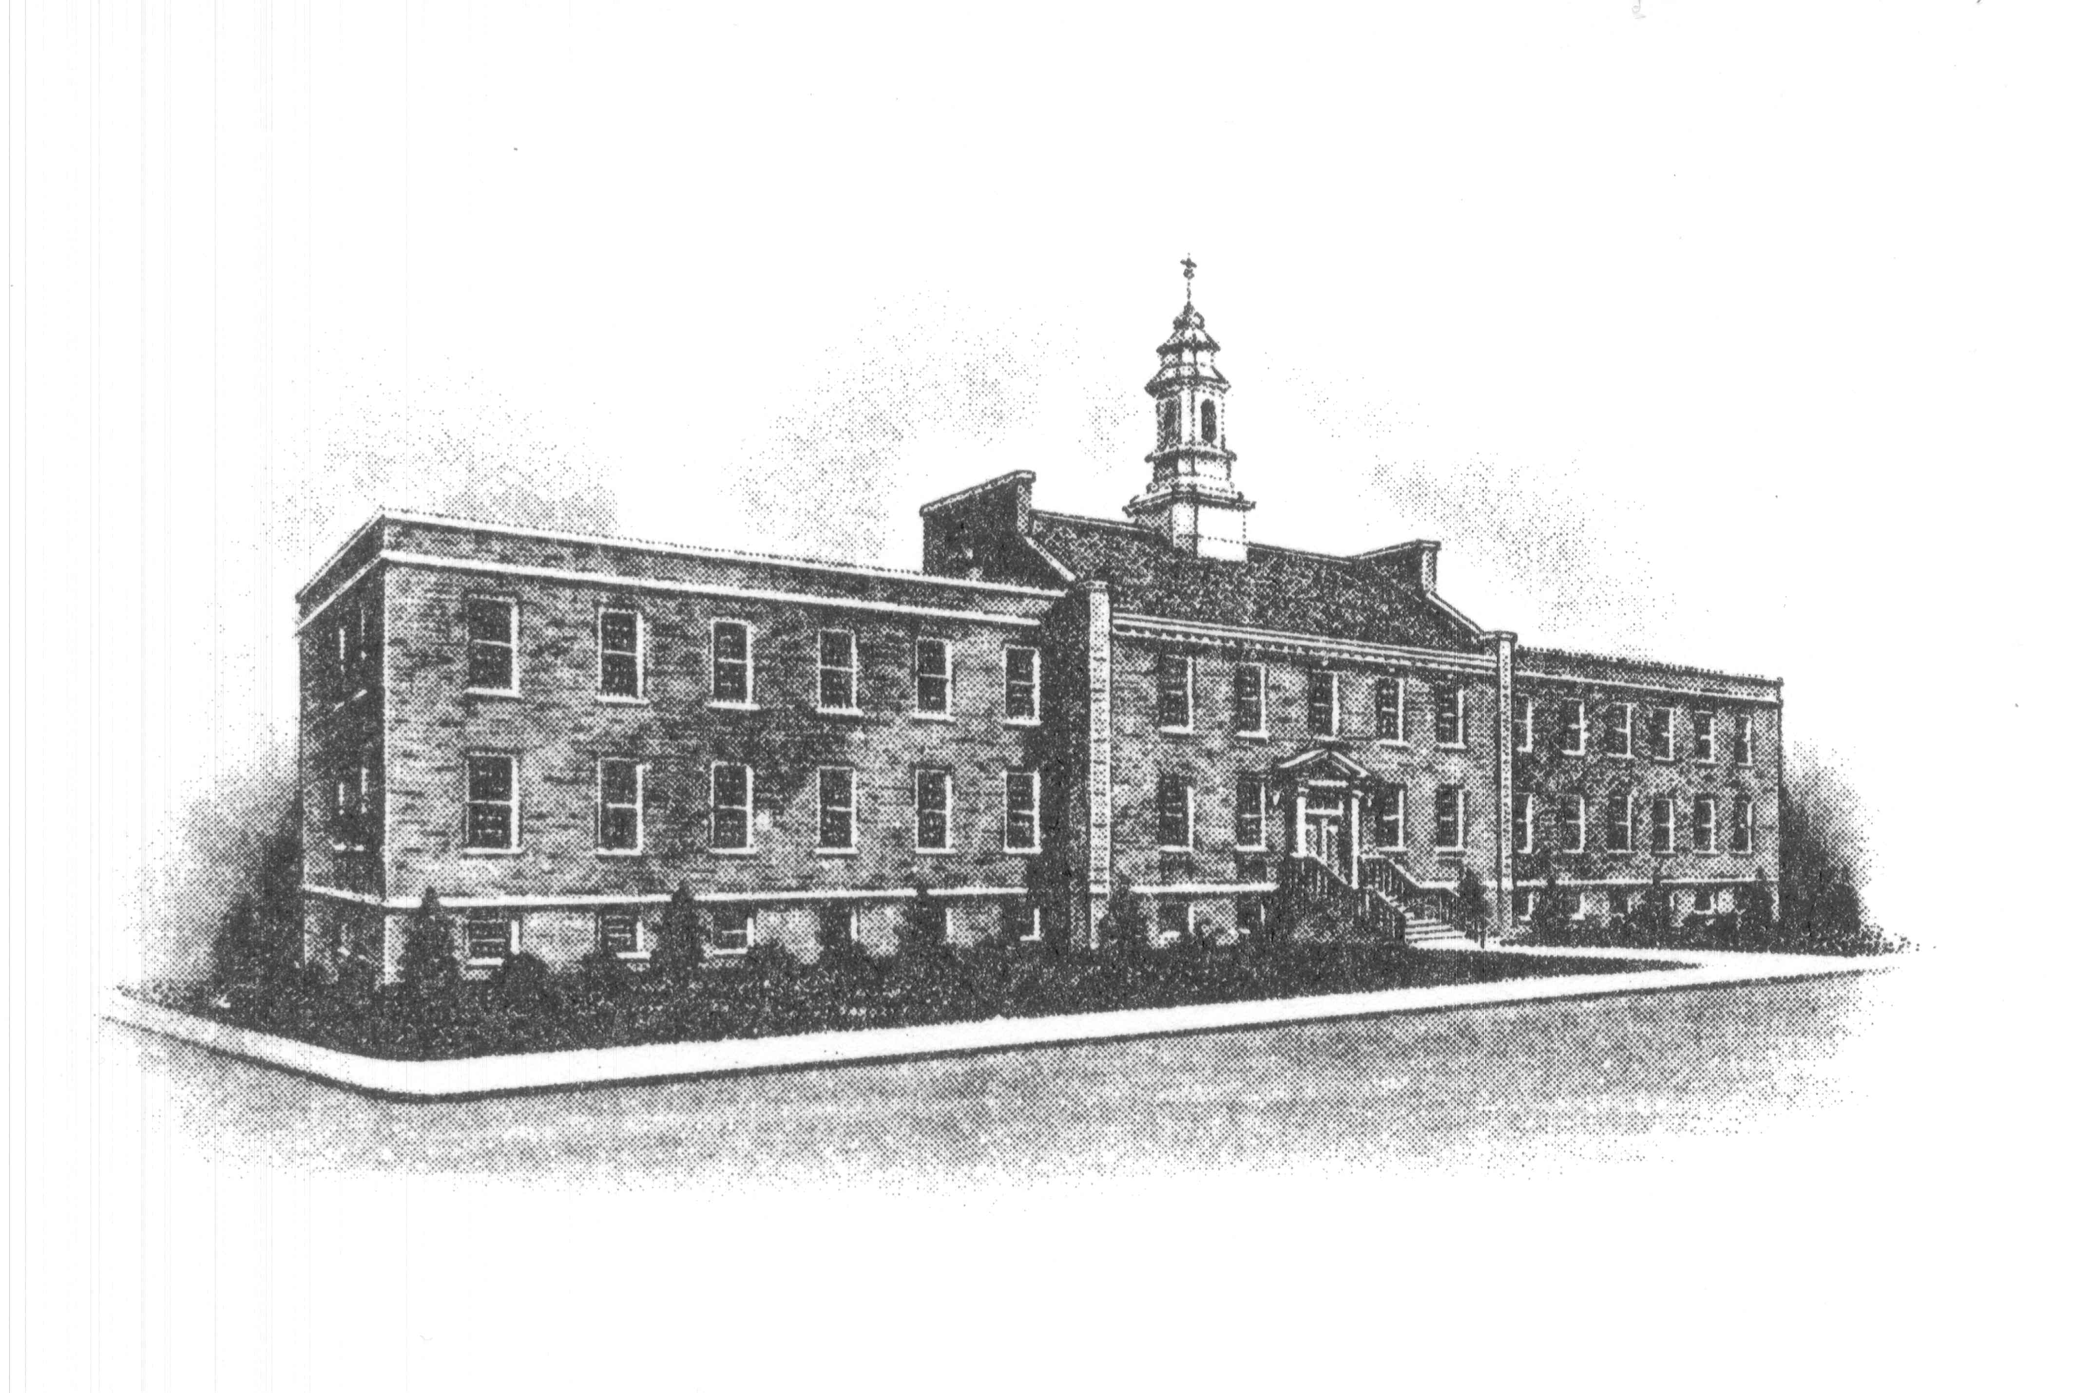
The Borough of Sayreville
Sayreville Economic & Redevelopment
Agency (SERA)
167 Main Street
Sayreville, NJ 08872
732-390-7077
FAX: 732-390-7458

MEETING UPDATE

BOROUGH OF SAYREVILLE
NOTICE OF PUBLIC MEETING
SAYREVILLE ECONOMIC & REDEVELOPMENT AGENCY

Please be advised that the Sayreville Economic & Redevelopment Agency (SERA) will be holding its regular meeting on Thursday, February 24, 2022 in the Borough Hall, Room 308 beginning at 6:30 p.m.

