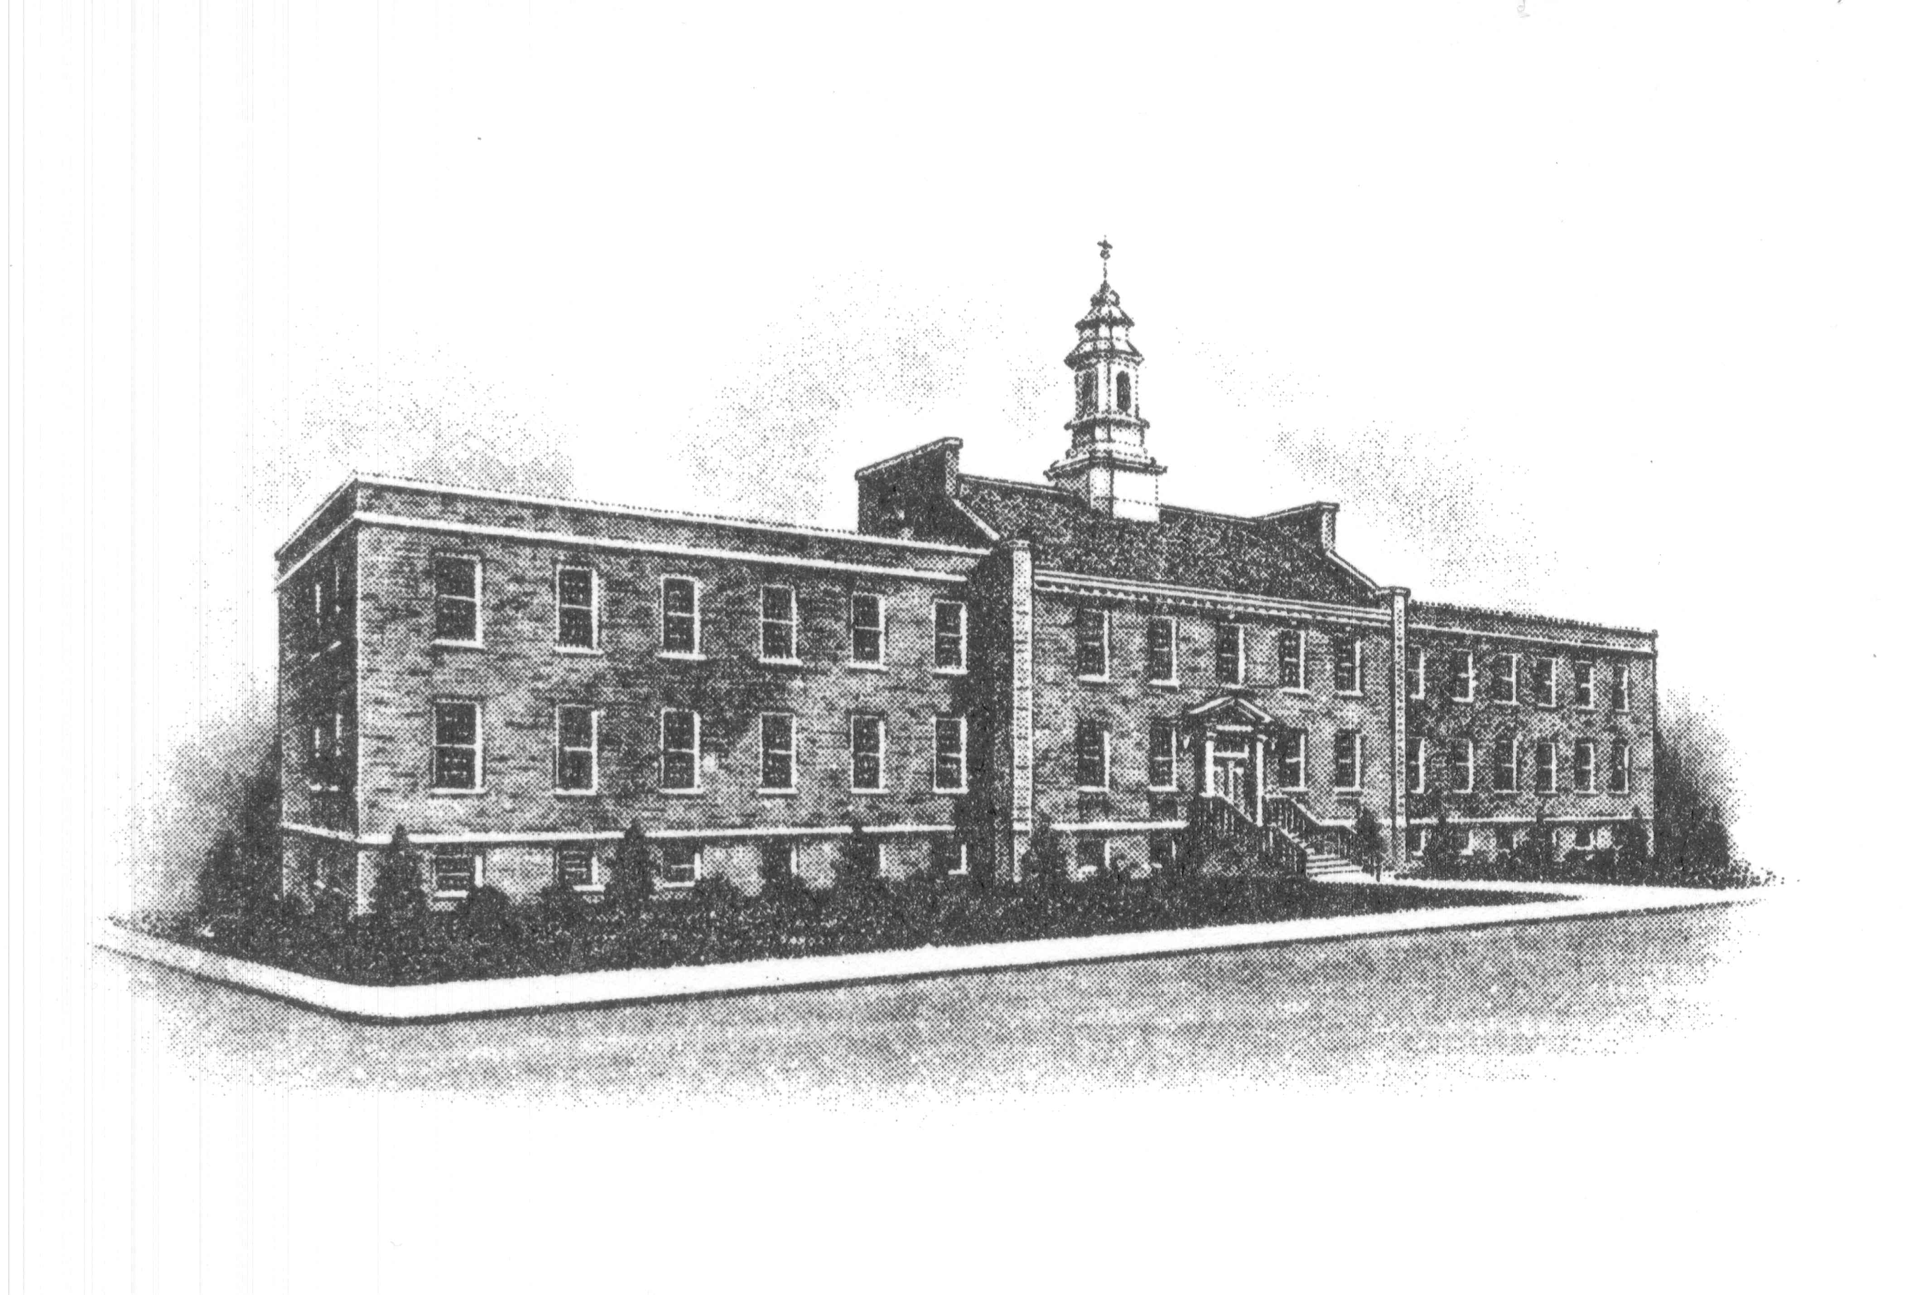
The Borough of Sayreville
Sayreville Economic & Redevelopment
Agency (SERA)
167 Main Street
Sayreville, NJ 08872
732-390-7077
FAX: 732-390-7458

MEETING UPDATE

BOROUGH OF SAYREVILLE
NOTICE OF PUBLIC MEETING
SAYREVILLE ECONOMIC & REDEVELOPMENT AGENCY

Please be advised that the Sayreville Economic & Redevelopment Agency (SERA) will be holding its regular meeting on Thursday, July 8, 2021 in the Borough Hall, Room 308 beginning at 6:30 p.m. and will continue in person meetings through the end of the year. We will notice the meeting dates for September through December when they are available.

If you have any questions, you may contact Joan Kemble, Board Secretary at 732-390-7077.

Thank you.

