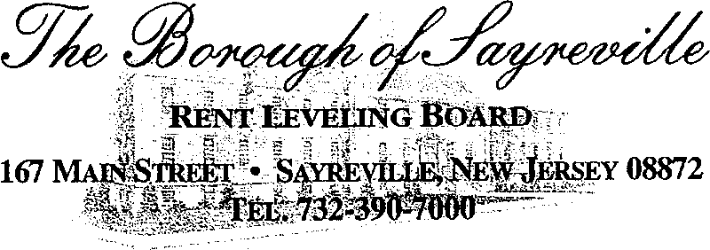

AGENDA FOR SEPTEMBER 8, 2020 – 6:30 P.M. VIA ZOOM
Join Zoom Meeting
https://nyu.zoom.us/j/97950549671
Meeting ID: 979 5054 9671
+1 646 558 8656 US (New York)

1. Roll Call

2. Acceptance of Minutes from June 9, 2020

3. Correspondence

4. Lease Renewals

5. Old Business

Ordinance #472-19 “An Ordinance Amending and Supplementing Chapter XII of the Revised General Ordinances of the Borough of Sayreville to Amend Section 12.6 Rent Control”.

Gillette Towers

6. New Business

7. Informal Requests from Floor

8. Adjournment

